**Central Tendency**

**Summarization of Below Table**

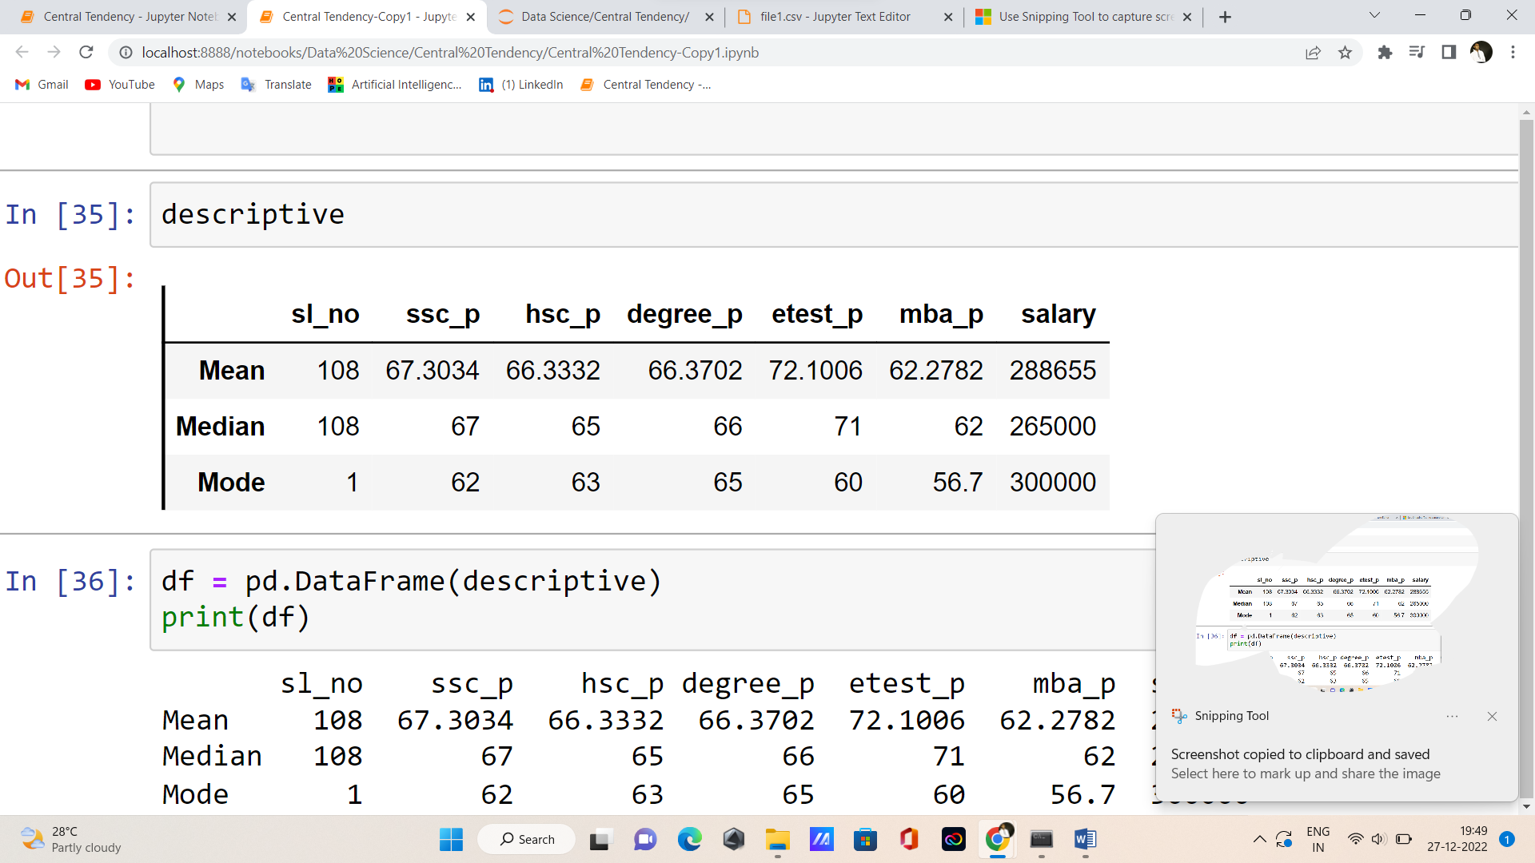

- from 10th standard to higher secondary and MBA percentage everyone got same range of Average Range.

- In entrance test alone they got 72% average.

- So I found outliers median of salary part.

- From mode I found repeated of all these.

|  |  |  |  |  |  |
| --- | --- | --- | --- | --- | --- |
| Sss_p | Hsc_p | Degree_p | Etest_p | Mba_p | Salary |
| 62 | 63 | 65 | 60 | 56 | 3,00,000 |

This is the summarisation of this table in my point.

Thank you